**Heuristic Evaluation Report**

Date: 11/14/2019

Prepared By (team member names): Colin Knebl

***Evaluation***

Name of website being evaluated: Happy Coffee

Describe the scenario you used to focus your evaluation:

I don’t want to wait in line at the coffee shop, so I want to visit the site and view the menu so I know what I want to order before I visit the store.

**Problem #1**

The menu is not available in the navigation bar, and there does not seem to be any way to access it from the home page (there is a not that says it is in the footer, but as a user I might not scroll to the footer).

Insert print screen, location of problem:

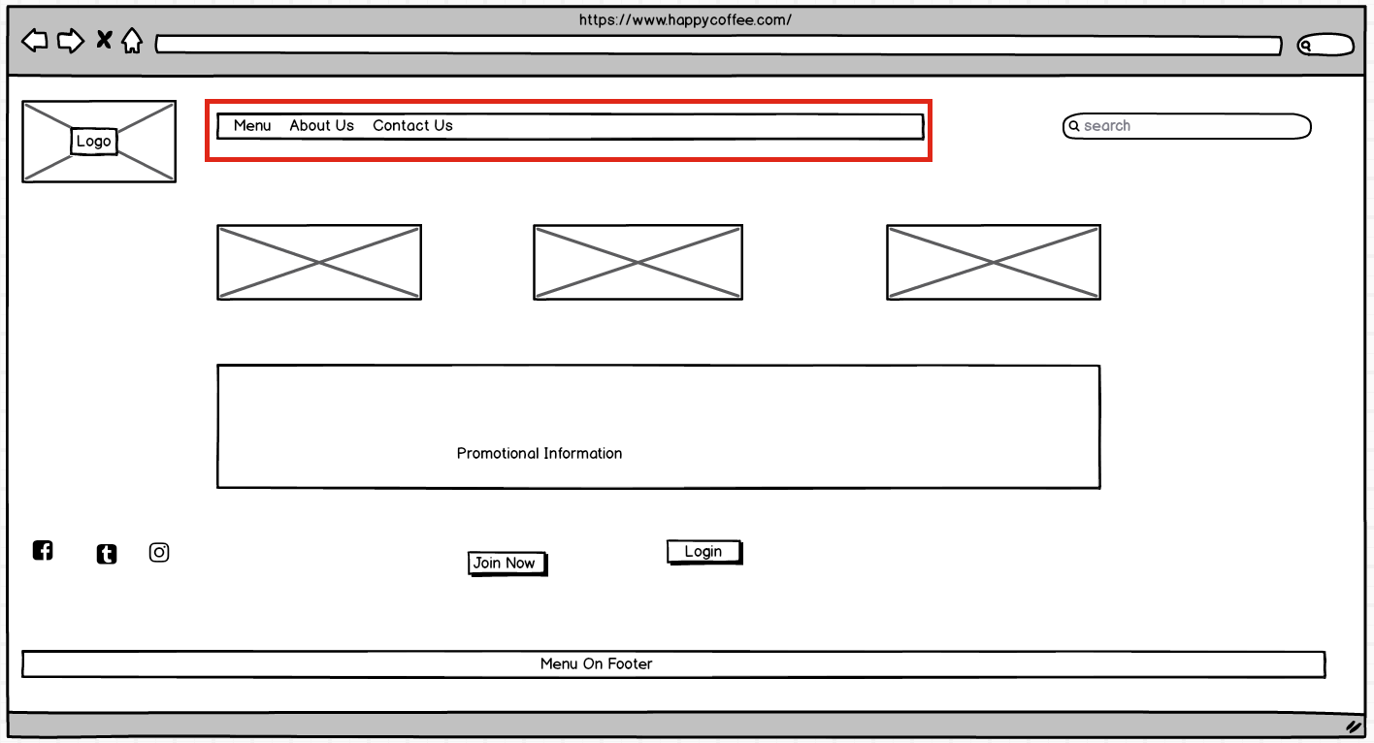

Name of heuristic: #6: Recognition rather than recall

Reason for reporting negative or positive: negative

Scope of problem: Navigation bar

Severity of problem (high/medium/low): High

Justification for severity rating: User may not find the menu which could make the go to a different coffee shop.

Suggestions to fix: Add a link to the menu in the navigation bar, consider adding a portion of the menu on the home page in the main content area with a link to view the whole menu

Possible trade-offs (why fix might not work): User may feel like the site is just trying to convert them into a customer

**Problem #2**

Home page may be difficult to navigate. The grid seems unevenly portioned and may cause the user to become frustrated and bounce from the page

Insert print screen, location of problem:

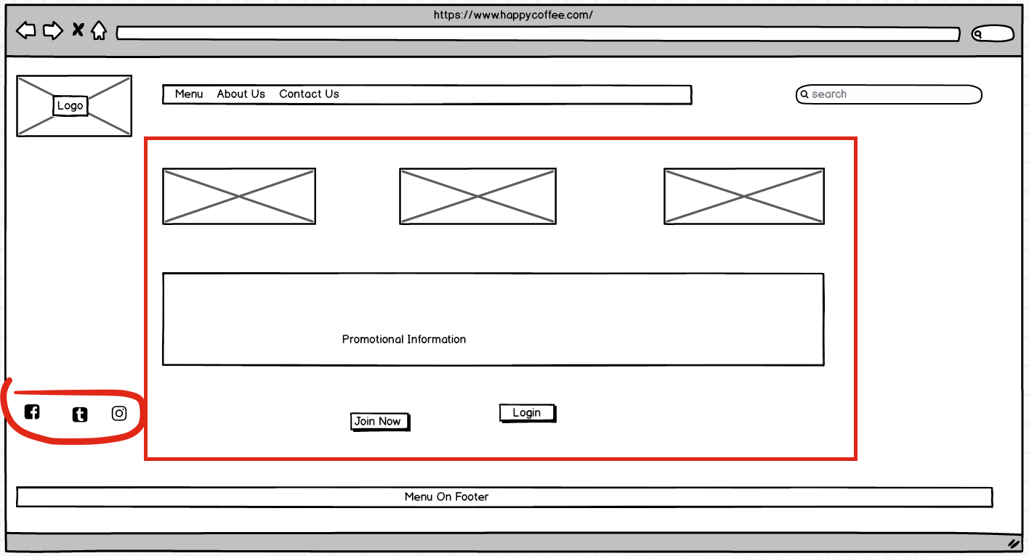

Name of heuristic: #7: Flexibility and efficiency of use

Reason for reporting negative or positive: negative

Scope of problem: All pages

Severity of problem (high/medium/low): medium

Justification for severity rating: the problem is just a visual problem, but it could cause users to bounce.

Suggestions to fix: ensure even spacing of grid and grid element throughout the site

Possible trade-offs (why fix might not work): user may not like grid layouts